# Individual Research Paper

# Topic: Proximity detection System

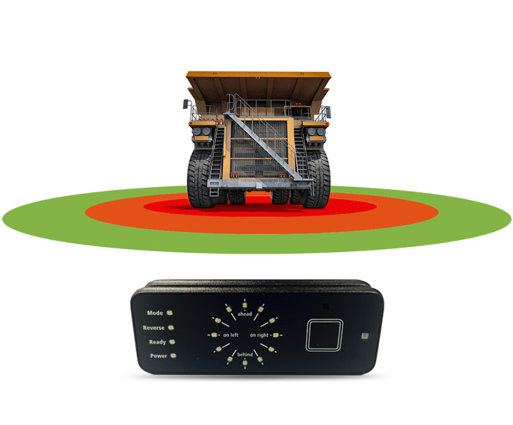

## Batch:25 B

## Coventry Id: 10261549

## Submitted By: Nitesh Paudel

## Submitted To: Shrawan Thakur

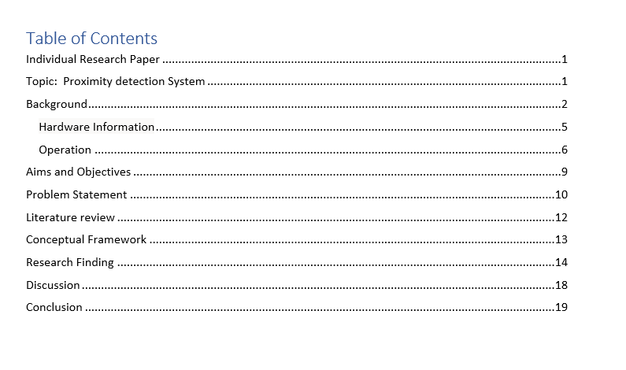

# 

# Background

The Proximity warning System (PWS) is intended to assist personnel in learning to manage a continuous miner from secure working zones and to also avoid danger zones. It is not meant to replace training and secure operating procedures; rather, it is a valuable tool to aid in the training of employees.

A continuous miner which is a machine that scrapes coal from the seam using a large rotating steel drum with tungsten carbide teeth. Operating in a “room and pillar” system – where the mine is divided into a series of 20-to-30 foot “rooms” or work areas cut into the coalbed – it can mine as much as five tons of coal a minute – more than a miner of the 1920s would produce in an entire day.

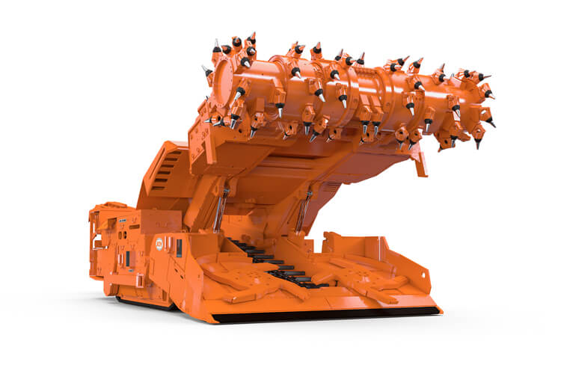

All staff entering the Longwall are provided a proximity tag. The tag sends out radio signals. The Control system detects these signals and uses them to determine the operator's location on the longwall. This protects the wearer while free running or shearer-initiated shield advance sequences are in use.

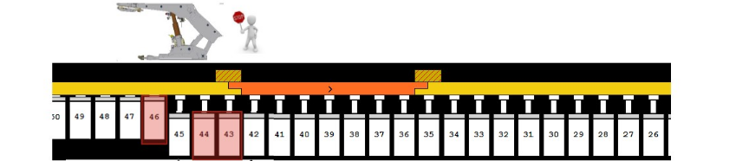

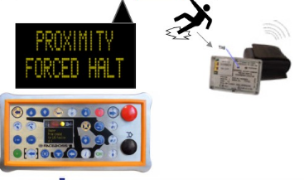

Free running while longwall mining is very dangerous and require you to reach depth up to 650m. Longwall mining is a form of underground coal mining in which a long wall of coal (typically 0.6–1.0 m (2 ft 0 in–3 ft 3 in) thick) is extracted in a single slice. The longwall panel (the mined block of coal) is normally 3–4 km (1.9–2.5 mi) long and 250–400 m (820–1,310 ft) high. The way of mining is thought to be the safest way to mine rather than Shortwall mining. Its more cost effective and has low operating cost which makes it go to method for large multinational companies. The initial setup cost is high as it uses advance technologies and machineries the method of the operation durable fast and productive at the same time.

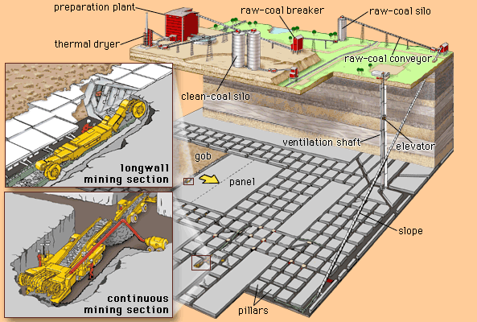

Proximity security ensures the mine that if an operator is found within the Halt Zone of an Automatic advancing shield, the shield will be stopped. The Faceboss function already allows operators to pause and unpassed primes in order to navigate through a dangerous area safely. Any identification of a Tag, as well as its movement along the Longwall and Stage loader/Tailpiece areas, will be noticeable on the Headgate Monitor.

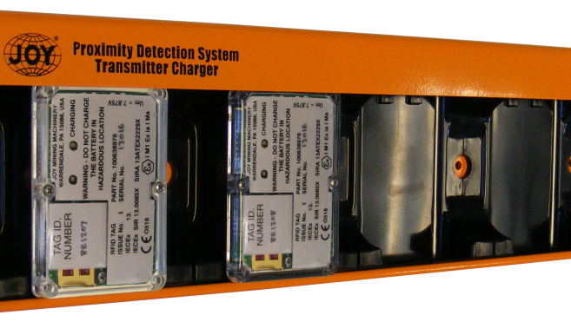

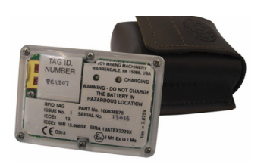

## Hardware Information

Proximity Tag

•Comes with a 2.4GHz radio transceiver and a rechargeable 2200mAh Li-Ion battery.

•Is entirely potted in a polycarbonate box.

•RS20s PRS and Headgate Field Mimics

•An integrated radio transceiver is also included.

•It makes use of the same 2.4GHz radio link as the tags.

•Utilizes relative RF obtained signal strength and quality of service algorithms to pinpoint the operator's location.

## Operation

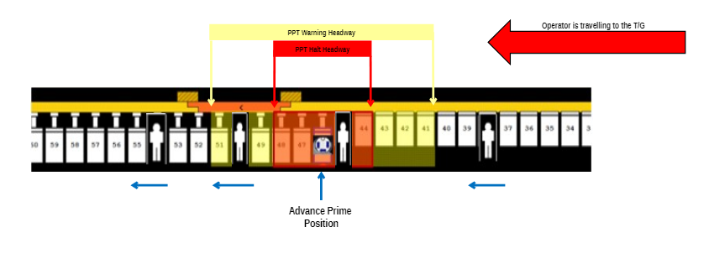

• A surface station is made up of an RS20s Mimic and an RS20s Micro. A computer will be linked to the device.

• The Mimic, Micro, and software are similar to those found underground on the longwall.

• Surface Test Station offers the following services:

• Assuring the wearer that their tag is in good working order until it is buried; and • Any flaws discovered in the hardware, battery life, software version, or boot process will be identified.

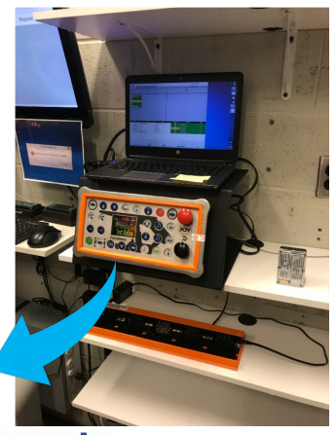

The operator will remove their Tag from the charging station and enter a marked test zone. When you enter the field, the Tag status and details are shown on the screen.

• Since the Tag is intelligent, all information is stored on it and uploaded to the system.

when the operator reaches the longwall underground.

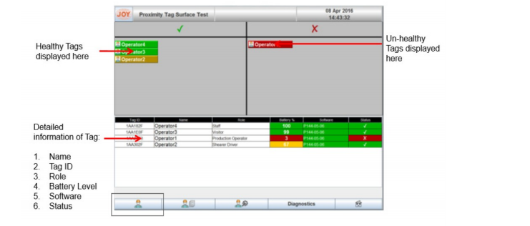

# Aims and Objectives

* Engineering Selection and Considerations Proximity Alert System Requirements for Mining Projects to decrease hazards and encourage productivity.

The first step in making mining machines safer is to recognize and determine the risks. Risk assessments may be used to determine goals, ensuring that the riskiest conditions are handled first and those that are unlikely to trigger significant problems are addressed later. Ergonomic risk factors that can jeopardize the safety of miners on the job. Those who must operate in close proximity to machines must also be considered. To analyze the relations between the worker and the computer, task analysis methods should be used. The findings can be used to correlate the operator's capabilities and shortcomings to the system's specifications. The resulting data can be used to not only build new machines, but also to improve existing ones. To ensure effective and secure operation, system design must regard the worker as a component of the system. Task analysis may also be used to define and promote the need for proper worker safety device implementation. Mining machines are getting more advanced and complex. Regulatory specifications also often had to be built into designs, which adds to the machine's complexity. In certain instances, little consideration has been given about how the integration of modern technology into devices impacts the human operators of this equipment.

During the conceptual design process, human factors should be discussed and integrated. If an ideal human factors solution is not available, appropriate countermeasures such as PWSs should be considered.

* Reducing the likelihood of accidental contact between miner and computer is a critical component of protection.

As a result, a variety of proximity detection tools and collision avoidance strategies have appeared on the market over the years, all with the aim of reducing – and eventually eliminating – these hazards.

But how does a mine assess which one is better suited to its requirements? Do you want a device that simply assists machine operators in seeing their surroundings before an accident occurs?

Or do you prefer a completely interactive device that senses potential hazards, sends alerts to personnel involved, and can intervene to avoid a collision? Different mining activities and working conditions necessitate varying levels of detection and protection, we discuss the various technologies currently available, evaluating their capabilities and highlighting a few pros and cons.

# Problem Statement

* Sight Lines, Fields of View, and Blind Areas.

Many mining machines, including big haul trucks, shuttle cars, and continuous mining machines, have problems with operator vision and lighting. These concerns have resulted in injuries and fatalities for both machine operators and nearby employees.

Most automobiles have blind spots that impair the driver's vision. This is particularly true for large construction and haul trucks. However, this is also valid of far smaller cars. Mirrors and cameras have been used to reduce the problem, but incidents still occur because the vehicle operator must first see the problem and then respond appropriately. Fog, dirty mirrors and glasses, and bad lighting. Driver exhaustion will impair the driver's ability to see other vehicles and pedestrians (workers on foot).

* Operator Attention and Fatigue

Remote-control continuous miner operators, like many skilled workers, go about their daily tasks, making choices and decisions that they do not consciously consider. They are constantly processing feedback and signals that direct their next step when performing tasks. Unfortunately, operators sometimes step alongside a moving continuous miner or beyond the supported roof for a better view while coal cutting or tramming

* Surface Versus Underground Considerations

Radar sensors present several interesting installation and positioning problems. In most cases, the shape of the signal provided by the sensor determines where it will be positioned. Falling debris, tyro motion, flying stones and mud, as well as rain, snow, and high dust concentrations, can all affect positioning. The machine operator's location is especially significant.

A radar-based system designed for a surface haul truck would clearly not fit for a remote-controlled continuous mining vehicle.

* Warning System Effectiveness

There is a lack of data on the performance of PWSs when installed on actual mining equipment. Many available technologies have been tested by NIOSH engineers in order to confirm their efficacy on massive off-highway dump trucks.

# Literature review

A look at the Technologies that drive Proximity Detection.

**Cameras:**

Cameras are simple to mount and relatively inexpensive; however, since they are passive devices with no active detection or alerts, they rely on the machine operator to control the screen in order to be successful.

**Rader:**

Radar systems operate by mounting a sensor at the front and rear (and sides as needed) of machinery to send out pulse waves and detect reflections or frequency changes. When such an indicator detects the presence of an object or a pedestrian, an alarm is produced for the machine's operator. Any object will be identified, and there is no need for a receiver/tag. Radar systems have a stable, dependable tracking capability for determining object location and distance. The direction of movement is meaningless with sensors mounted on both the front and back. Since radar is susceptible to alarm triggers when any object enters its field – regardless of its nature – benign objects can cause false detects and nuisance alarms, resulting in loss of efficiency.

**RFID:**

RFID systems for proximity detection in mining and construction work by using an "activator" mounted on machinery and small battery-powered "tags" worn on a miner's person. The activator emits RF pulses to create a "read zone" around the unit, and any tag within range is triggered, as the name implies. As this occurs, the tag sends a position signal to a device.

**Ultra-Wide Band (UWB):**

Ultra-Wide Band is a newer technology that creates two-way communication between device transceivers by using a broad spectrum of radio frequencies. Personnel carry transceivers, which are mounted on equipment and vehicles. The RF signals' time-of-flight (ToF) is used to calculate the distance between and location of the objects. UWB has the advantage of extremely precise positioning, enabling operations to define various levels of proximity zones, such as "alert" or "hazard" zones. Two-way contact between transceivers ensures that if an impending collision is observed, both parties are notified.

**Electromagnet**

Field generators and personnel-worn receivers are used in electromagnetic systems. The generators are mounted on equipment and establish electromagnetic zones around the device. Personnel wear Personal Alarm Devices (PADs), which detect these zones and send out warning warnings to all parties when they are violated.

# Conceptual Framework

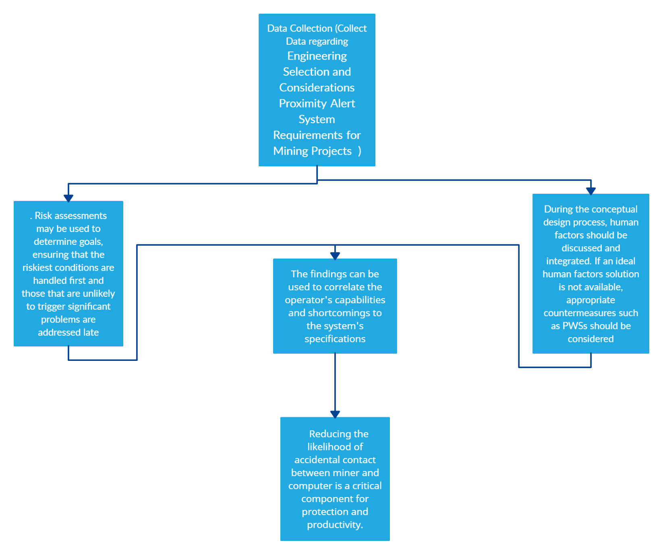

# Research Finding

The SmartZone Proximity System is intended to make things safer for miners using simple IOT. The findings of the research are mainly based on how good the system works rather than how it’s made. The system can be exemplary but its error expectancy will never be zero. How can we establish a safe zone between the technology hazards with its user? Integrating technology with heavy machinery and in situation’s which can be life threating and dangerous takes a lot of expertise and experience. The Risk assessment must be done to determine the main goals and ensuring the riskiest condition are assed first and those lest likely to create significant problem should be assessed last. Because of the number of workers close to the machine and the variety of ways the machine can shift, pivot, and tram, continuous mining machines, the rule's initial target, present one of the most significant safety challenges. The working environment around underground mining machines is extremely dark and enclosed. It is common for equipment to be driven close to mine entry walls, and the orientation of the walls is used to help guide the vehicles. Furthermore, vehicles sometimes collide while loading and unloading ore or coal. Operators are not necessarily aware of their assistants' positions. the position of their helpers and/or any other person who may be in the work area. A Proximity Warning System (PWS) marker on each worker that is activated as he or she approaches a dangerous area could alert the operator and prevent a potential injury or fatality. Since 1984, 33 miners have died after being hit or pinned by a continuous mining machine. According to MSHA, a proximity detection device that disabled the unit could have prevented 80% of the 33 fatalities. According to MSHA, proximity detection technology has the potential to avoid up to 20% of all mining-related fatalities. NIOSH has evaluated commercially available systems as an unbiased third party and is designing a prototype intelligent device that offers enhanced security by continuously monitoring miners' positions in relation to the machine and developed safety zones. About ten years ago, NIOSH developed electromagnetic proximity detection technology as the Hazardous Area Signaling and Ranging Device (HASARD). This system employs an electromagnetic field generator to generate a magnetic field that can be measured by a wearable Personal Alarm Device (PAD), providing a rough indication of the distance between the generator and the PAD. While these systems certainly increase miner protection, they still only describe a large area around the machine in which the miner is located. With the introduction of a more intelligent device, a higher degree of security is feasible. This enhanced security will be provided by the NIOSH IPD device, which will continuously monitor the locations of all miners near the machine and make situational decisions. Based on these positions, make decisions Instead of fully shutting down the mining machine, the IPD device just prevents potentially dangerous machine motion. The IPD system improves operator acceptance by reducing the annoyance associated with regular false alarms and complete stops of all machine operations, in addition to offering more intelligent security. HASARD (Hazardous Area Signaling and Ranging Device) is an active proximity alert system established by NIOSH to alarm workers as they enter known dangerous areas around heavy mining equipment and other dangerous work zones. HASARD is made up of two parts: a transmitter and a receiver. Using one or more wire loop antennas, the transmitter produces a magnetic field at 60 kHz. Each antenna is calibrated to create a magnetic field pattern specific to each hazardous region. The worker's receiver is a magnetic field strength meter. The obtained signal is compared to predefined levels that have been optimized to distinguish levels of risk. Visual, auditory, and vibrato outputs can be provided by the receiver. The worker's receiver is a magnetic field strength meter. The obtained signal is compared to predefined levels that have been optimized to distinguish levels of risk. The outputs of the receiver may include visual, auditory, and vibratory indications, as well as the ability to disable system functions. HASARD was tested in the field on three different machines: a Joy 12 continuous miner, a Komatsu 210 M Haulpak, and a highwall launch vehicle. For each submission, minor changes were made. HASARD delivered the intended alerts and proved to be tough enough to withstand the harshest manufacturing environments. The MineAlertTM Collision Awareness System (CAS) is an early-warning system that alerts equipment operators to possible collisions with other CAS-equipped vehicles, thus improving operator safety awareness and lowering the risk of vehicle-to-vehicle collisions. Predictive algorithms analyze the location, speed, and trajectory of all vehicles in the monitored area to reduce false alarms, generating warnings only when potentially hazardous conditions occur. The MineAlert CAS enhances your operators' situational awareness and system confidence by creating warnings that they genuinely trust, assisting you in driving a zero-harm workplace. Determine the collision risk of a vehicle based on its travel speed, instantaneous direction, expected course, and other factors.

Without pause, alert operators of possible hazards, allowing them to take corrective steps to avoid a collision. Separate true collision risks from simple proximity incidents, such as when two haul trucks pass each other on the same lane. Consider the following vehicle-to-vehicle crash scenarios:

* Collisions in the forward direction (FCW)
* Collisions during take-off (TOW)
* Collisions that are head-on (HOC)
* Infractions of the speed limit
* omissions
* Intersections for Overtaking (IMA)

# Discussion

Reducing the likely hood of accident with machines and man will always be a continuous task. The papers findings are based on how can we minimize damages and improve productivity. The error which can happen in those critical situations can be life threating. However, there are lot of improvements in PWS equipment which can be done to improve safety for the workers using it. That research can help improve lot of miners’ quality of work and stop lot of critical problems. The introduction of large mining trucks has exacerbated the ongoing issue of accidents caused by poor external vision and reduced maneuverability. Determining the blind zones around a vehicle is a significant step toward determining which PWS is ideally suited for a given situation. Several standardized methods for evaluating blind zones have been developed, including the Rear Visibility Index [Paine et al. 2003]; "Earth-Moving Machinery, Operator's Field of View" - ISO 5006 [ISO 1991]; and "H-Point Machine and Design Tool Procedures and Specifications" - Society of Automotive Engineers standard SAE J826 [SAE 2002]. The NIOSH Spokane Research Laboratory created a more condensed version. Worker fatigue has undoubtedly played a role in multiple fatalities. The worker may be aware of the looming danger, but it may not register in his or her mind. A "wake-up" call from a PWS can be beneficial. When employees repeat a task many times, it becomes so automatic that the job no longer needs attention. Their minds will wander, leaving them unresponsive to potentially dangerous events. Fatigue is an issue in any 24-hour service. Our biological clocks immediately move the brain to low levels of alertness after lunch and during the night to trigger sleepiness. As a result, mine workers are ill-equipped to maintain alertness and efficiency during nocturnal work hours or to get enough sleep during the day.

Vehicle drivers are unable to gaze directly through the rear window while still seeing the view in the side and rear-view mirrors. If an obstacle is in the path of the car, an audible warning may help to improve the situation. Rear-facing video cameras with a display fixed in the cab may be useful. It is critical that a PWS chosen for a job be able to function consistently in the given job setting. Radar sensors present several interesting installation and positioning challenges. In most cases, the shape of the signal produced by the sensor decides where it will be positioned. Falling debris, tyre motion, flying stones and mud, as well as rain, snow, and high dust concentrations, can all influence positioning. The machine operator's location is especially significant. A radar-based system designed for a surface haul truck would clearly not work for a remote-controlled continuous mining vehicle. The operator of a continuous mining machine spends a lot of time close to the mine walls, long power cables, and shuttling equipment. The operator of a continuous mining machine spends a lot of time close to the mine walls, which would constantly activate a radar device. Similarly, since the mining machine operator usually carries the remote-control, a camera and video display device commonly used on surface haul trucks may not be suitable for continuous mining machines.

# Conclusion

The primary purpose of the research paper was to explore how The Proximity warning System works and how further improvements in the system can enhance safety for miners. The exploration of whether tweaking the system to enhance its performance in different situation can be effective to use the system in different situation. Training miners to use the system more effectively. Such topics have been explored. The proximity system can be improved drastically with some minor addition of different technology. These can make this system error free and safe for all new and old miners.